DEPARTMENT OF COMMERCE
Name of the Faculty |  | Designation | Qualification | Additional Charge | Experience | Contact Details
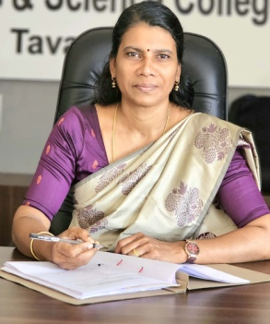 | Rema. K | Associate Professor & Head | M.Com, B.Ed, UGC-NET | HoD Commerce, PTA Secretary | >18 Years | remabaijujagath@gmail.com  9497631905
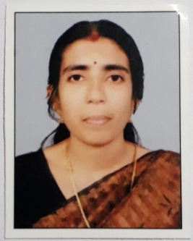 | Indu. P.P | Assistant Professor | M.Com, B.Ed, UGC-NET | Hunger Free, RUSA/AISHE | >15 Years | indurajesh2009@gmail.com9495657580
 | Vineeth. T.P | Assistant Professor | M.Com, M.Phil, UGC-NET | Admission, FYUGP, Website, College Portal, RTI-PIO, ICC | >8 Years | vineethgasct@gmail.com  9946331897
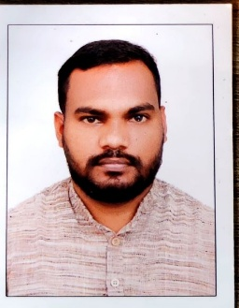 | Anil Puthanazhi | Guest Faculty | M.Com, B.Ed, UGC-NET |  |  | puthanazhi@gmail.com  9048766071

