DEPARTMENT OF SOCIOLOGY
Name of the Faculty |  | Designation | Qualification | Additional Charge | Experience | Contact Details
 | Sreejith. K | Assistant Professor & Head | MA, UGC-NET | HoD, Purchase Committee, Jeevani | >14 Years | sreejithmathil@gmail.com  9947303135
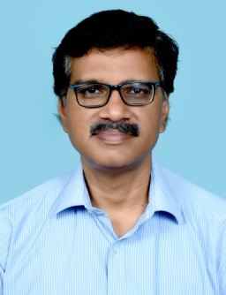 | Vinod. C.V | Assistant Professor | MA, UGC-NET | IQAC, Grievance Cell | >6 Years | thankugod@gmail.com  9495882248
 | Dr. Shafeeque. K | Guest Faculty | MA, PhD, UGC-NET | Arts & Sports |  | poraishafe@gmail.com  9943578514

