DEPARTMENT OF POLITICS
Name of the Faculty |  | Designation | Qualification | Additional Charge | Experience | Contact Details
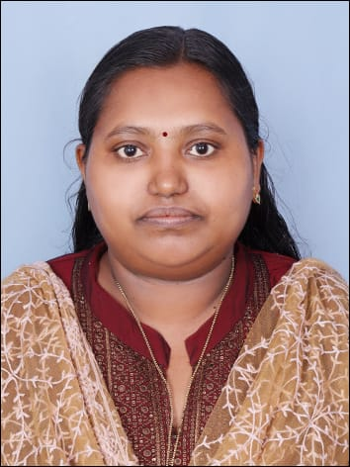 | Kavitha. K.K | Assistant Professor & Head | MA, M.Phil, UGC-NET | HoD Politics | <1 Year | 9400821681
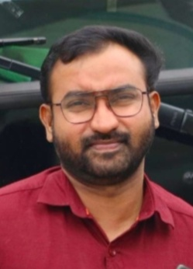 | George Varghese Chacko | Assistant Professor | MA, B.Ed, M.Phil, SET, UGC-NET, PGDJ | Examination Committee | <1 Year | 9447116717
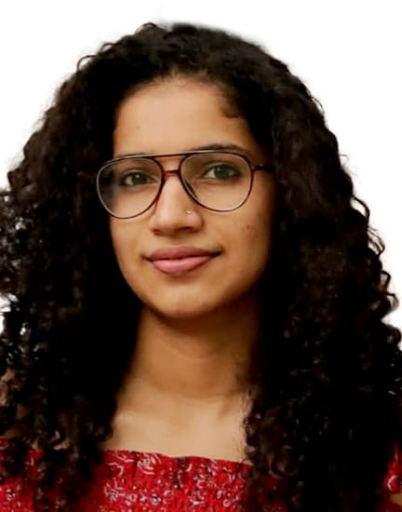 | Dr. Gayathry Gopal | Assistant Professor | MA, M.Phil, PhD, UGC-NET | Examination Committee | <1 Year | 9995984179
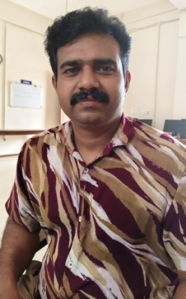 | Dr. Renjith Kumar O.S | Guest Faculty | MA, M.Ed, PhD, PDF, UGC-NET | Arts & Sports, College Magazine | <5 Year | renjithoskumar@gmail.com  9496467908
 | Muhammed Shafeek P.K. | Guest Faculty | MA, UGC-NET | Women’s Club | <2 Year | shafeekponnengadan@gmail.com  8113012788

