DEPARTMENT OF ENGLISH
Name of the Faculty |  | Designation | Qualification | Additional Charge | Experience | Contact Details
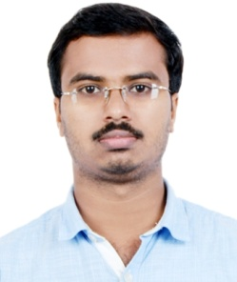 | Unnikrishnan. K | Assistant Professor & Head | MA, M.Phil, UGC-NET | HoD English, Canteen | >12 Years | nostoman86@gmail.com 9747382563
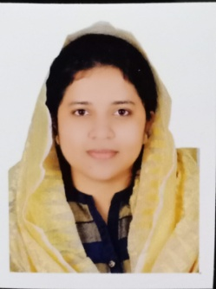 | Suhana Sathar. A | Assistant Professor | MA, M.Phil, UGC-NET | Examination, Women Cell | >6 Years | suhanasathar@gmail.com 7083661525
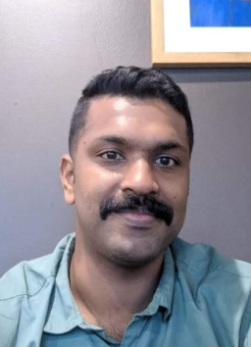 | Aravindan. S.S | Assistant Professor | MA, UGC-NET | NSS | >10 Years | aravindkazak@gmail.com 9446030860
 | Sabina K Musthafa | Guest Faculty | MA English, MA Journalism, UGC-NET |  |  | sabinakm@gmail.com 9567538276
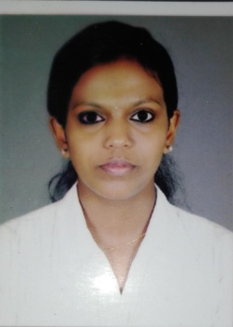 | Amitha C.G | Guest Faculty | MA, UGC-NET | Nature Club |  | amithacg3@gmail.com  9526848192

